**TEST 1**

*Program Start*

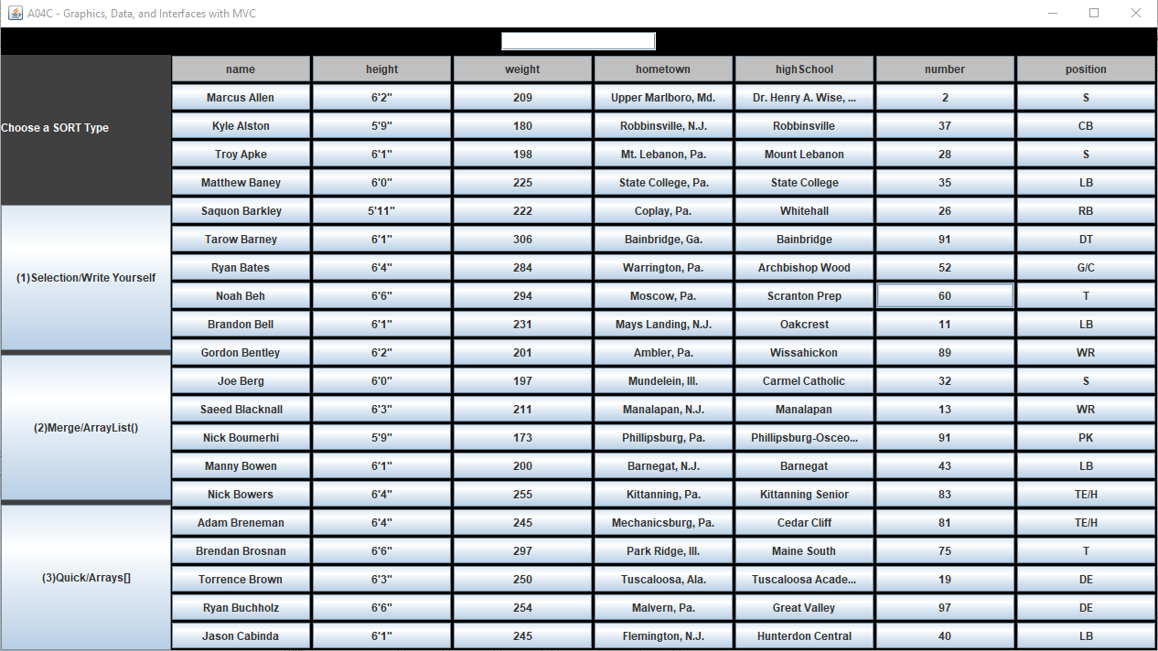

*Select weight column and search 245 (searching unsorted table)*

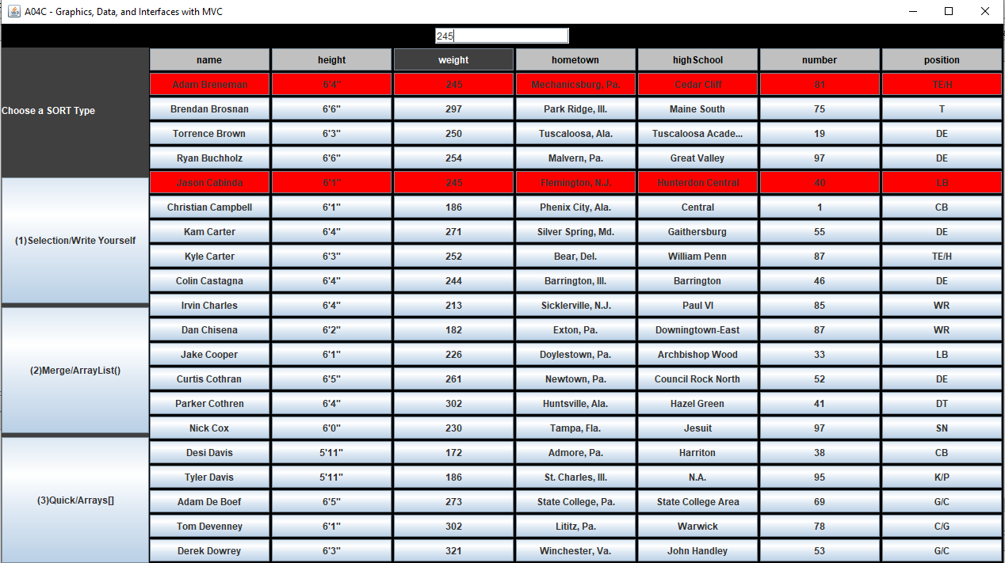

*Select weight column again (resets search and table)*

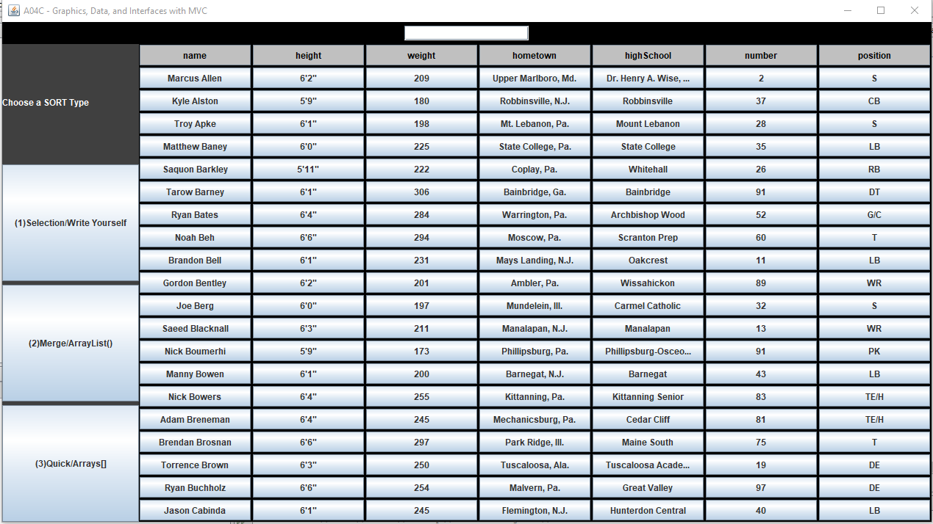

**TEST 2**

*Program start*

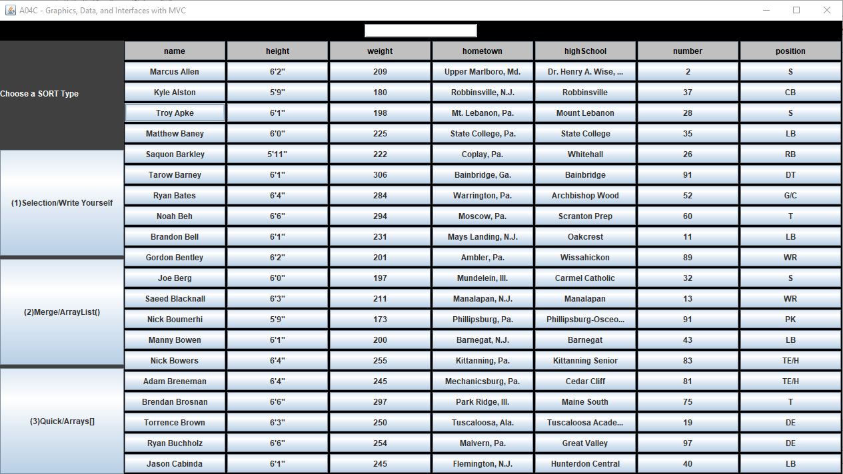

*Selection sort then select number column (sorts table by number)*

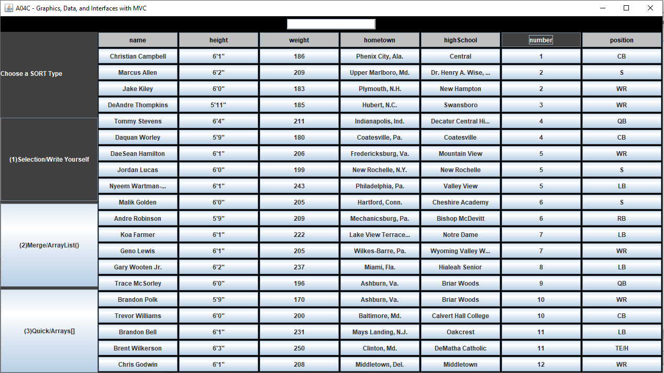

*Type 5 in search bar and press enter key (searching sorted column)*

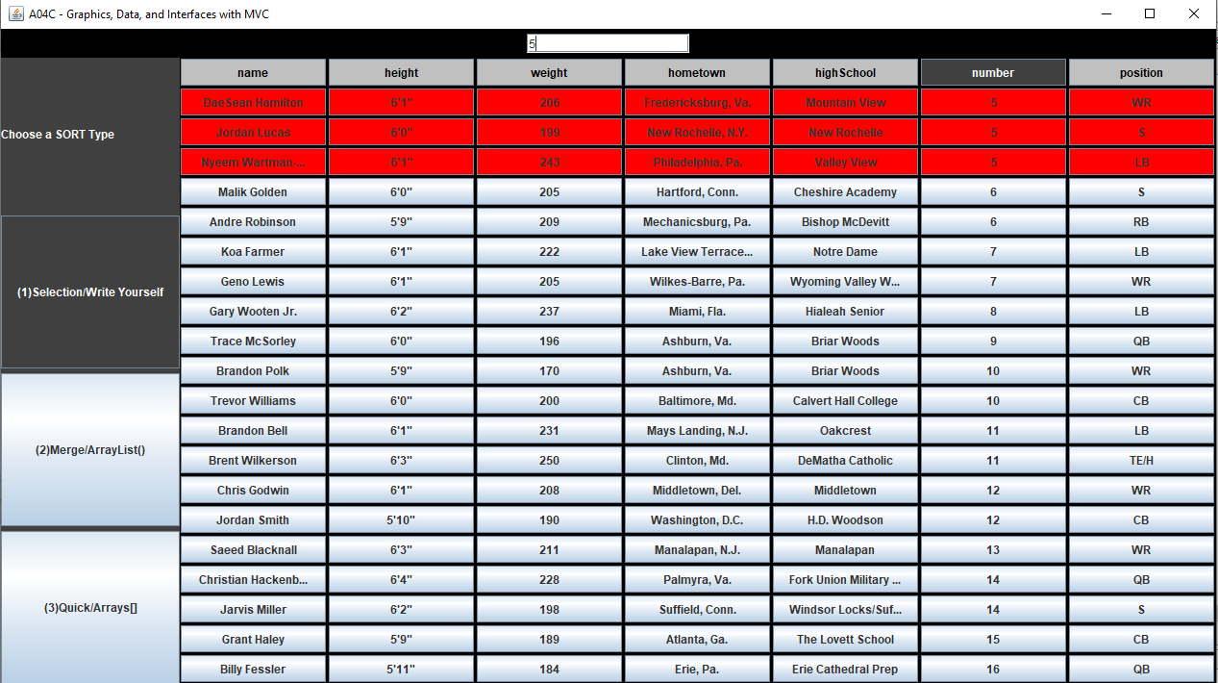

*Select hometown column (resets search and resorts table by hometown, preserves table scroll position)*

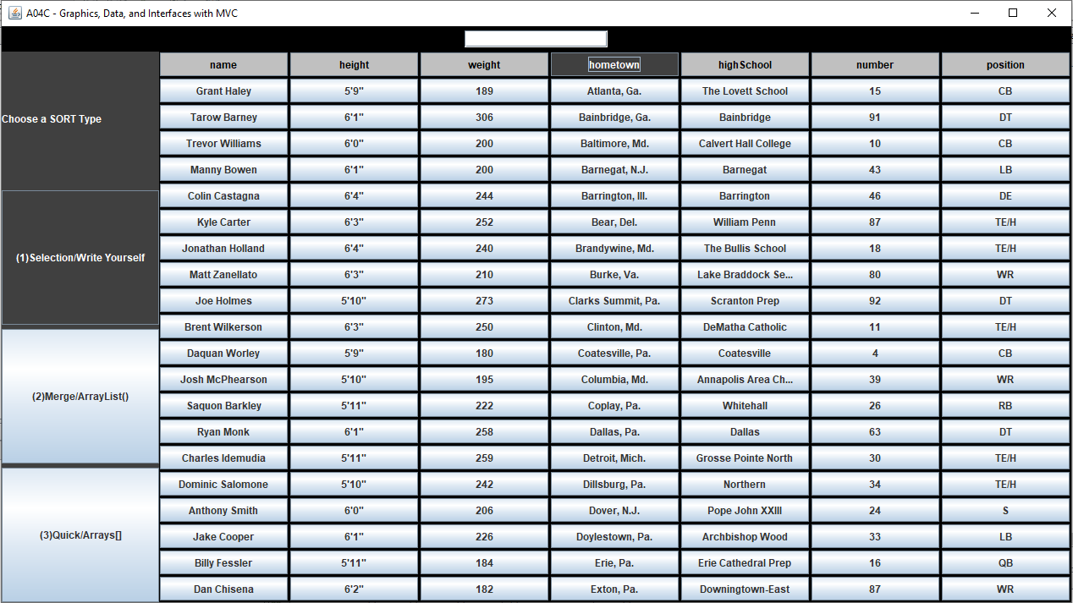

**TEST 3**

*Program start*

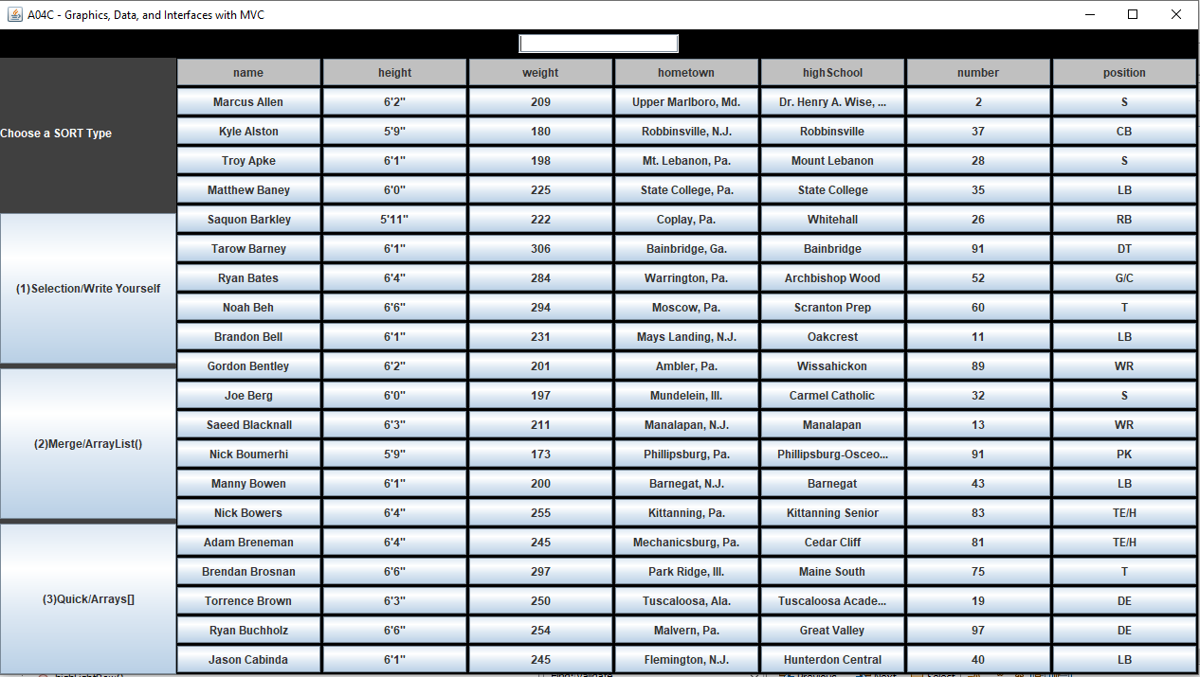

*Select merge sort and click position column*

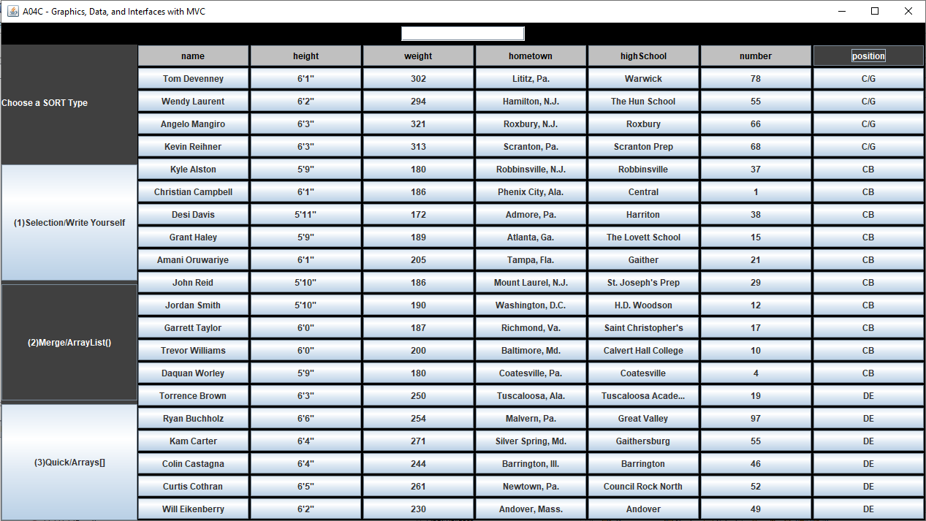

*Type WR into search bar and press enter key (Search result at bottom of the table)*

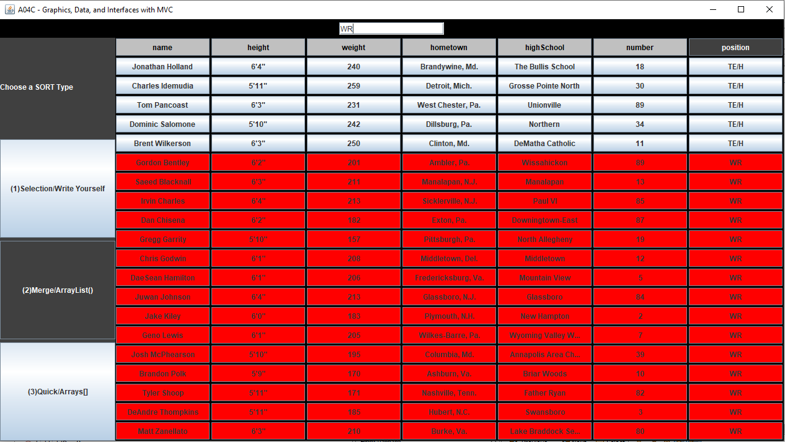

*Type apple into search bar and press enter key (invalid search)*

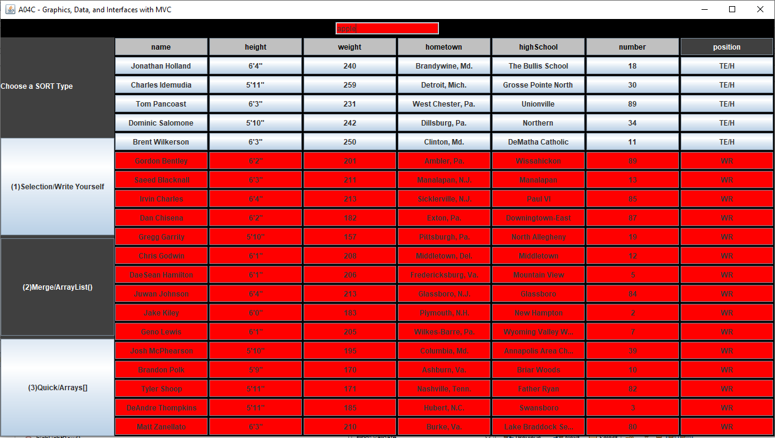

*Type TE/H into search bar and press enter*

